**SQL Case study: Danny’s Dinner**

**Introduction**:

Danny seriously loves Japanese food so in the beginning of 2021, he decides to embark upon a risky venture and opens up a cute little restaurant that sells his 3 favourite foods: sushi, curry and ramen.

Danny’s Diner is in need of your assistance to help the restaurant stay afloat - the restaurant has captured some very basic data from their few months of operation but have no idea how to use their data to help them run the business.

**Business Requirement:**

Danny wants to use the data to answer a few simple questions about his customers, especially about their visiting patterns, how much money they’ve spent and also which menu items are their favourite. Having this deeper connection with his customers will help him deliver a better and more personalised experience for his loyal customers.

He plans on using these insights to help him decide whether he should expand the existing customer loyalty program - additionally he needs help to generate some basic datasets so his team can easily inspect the data without needing to use SQL.

Danny has provided you with a sample of his overall customer data due to privacy issues - but he hopes that these examples are enough for you to write fully functioning SQL queries to help him answer his questions!

Danny has shared with you 3 key datasets for this case study:

* sales
* menu
* members

After hearing to Danny I assured him that I will help him to get answers to those queries and provide insights where ever possible. To do our task lets understand the schema and tables first.

**Understanding Schema and Tables**:

It’s really essential to understand the schema. It tells us how data is stored, relationships among the tables, and features of the table.

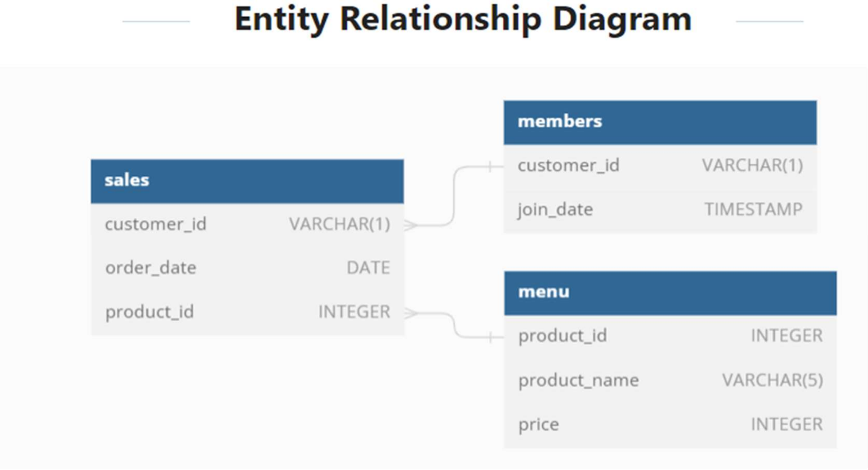

**Sales Table**: **Menu Table**:

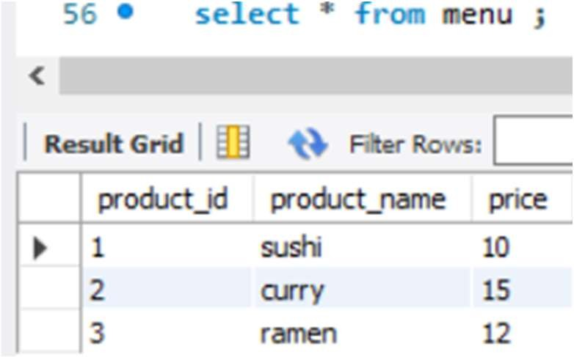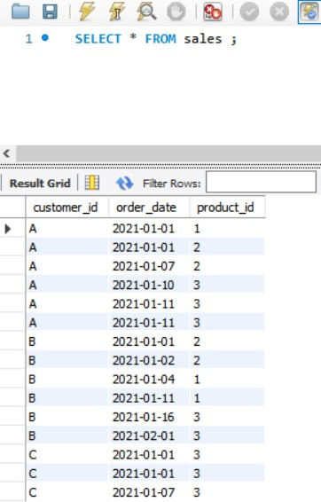

**Members Table**:

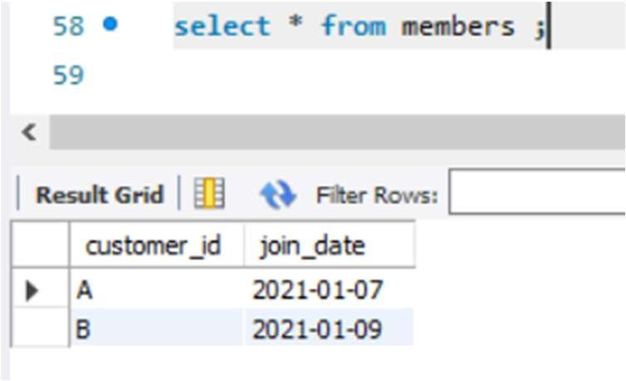

1. **What is the total amount each customer spent at the restaurant?**

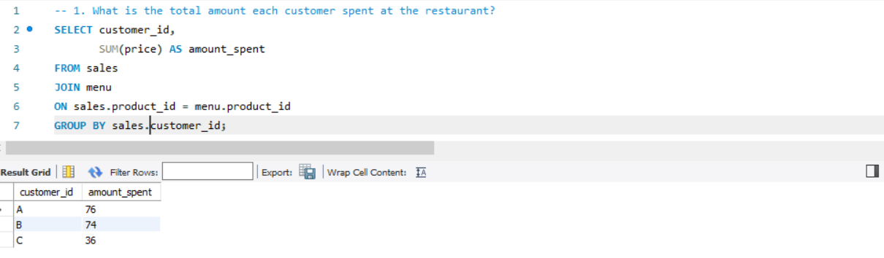

**Insights:**

It seems that customer A and B are big foodie because amount spent by them is more than 100% of customer C, so it will be more viable to invest on customer A and B.

1. **How many days has each customer visited the restaurant?**

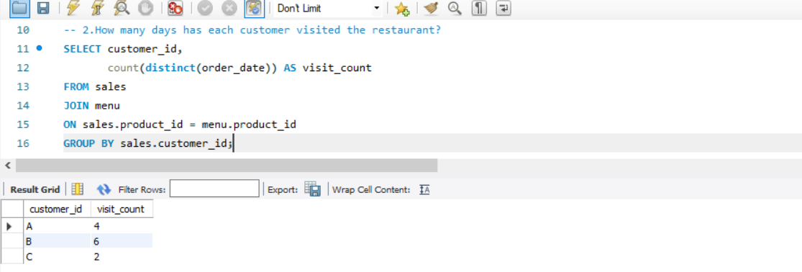

**Insights:**

From above results it is clear that customer C visits Danny’s restaurant more often the others. It might be because of he is loving Danny’s dishes.

1. **What was the first item from the menu purchased by each customer?**

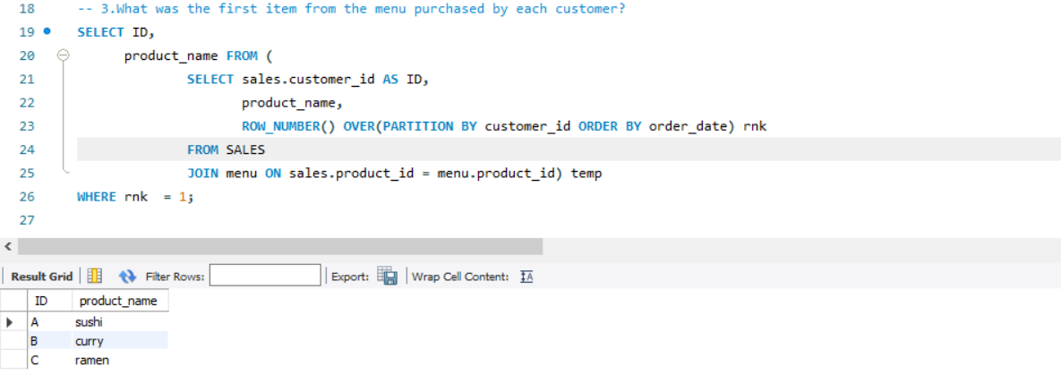

1. **What is the most purchased item on the menu and how many times was it purchased by all customers?**

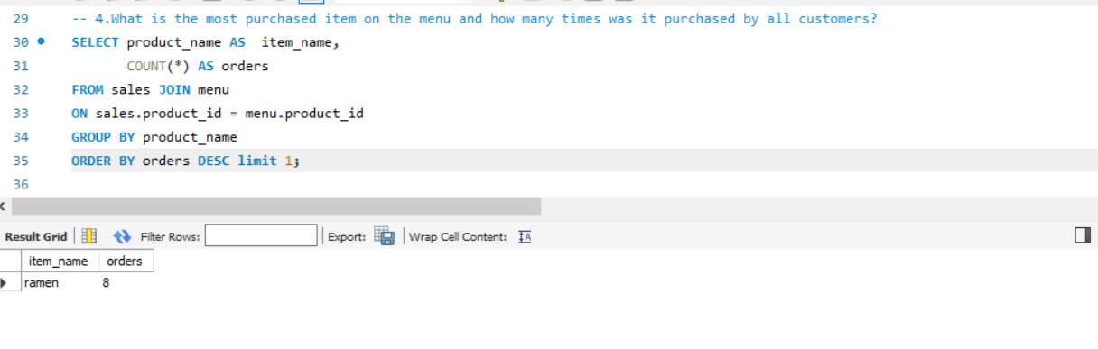

**Insights:**

Ramen was ordered the most, which means that people are loving this dish and we can increase the orders in future if we give slight discount to those customers.

1. **Which item was the most popular for each customer?**

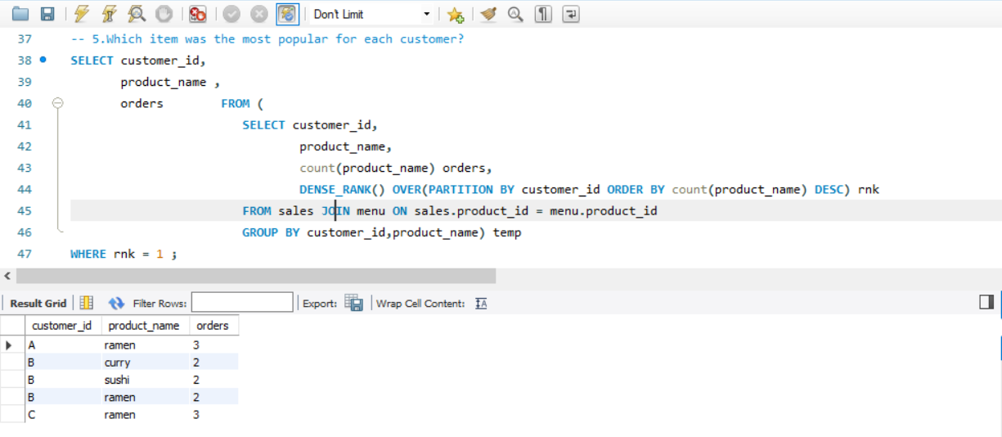

**Insights:**

From above output it is clear that out of 8 total ramen orders 6 came from 2 customers A and C. So these two customers will be on top of our recommendation list.

1. **Which item was purchased first by the customer after they became a member?**

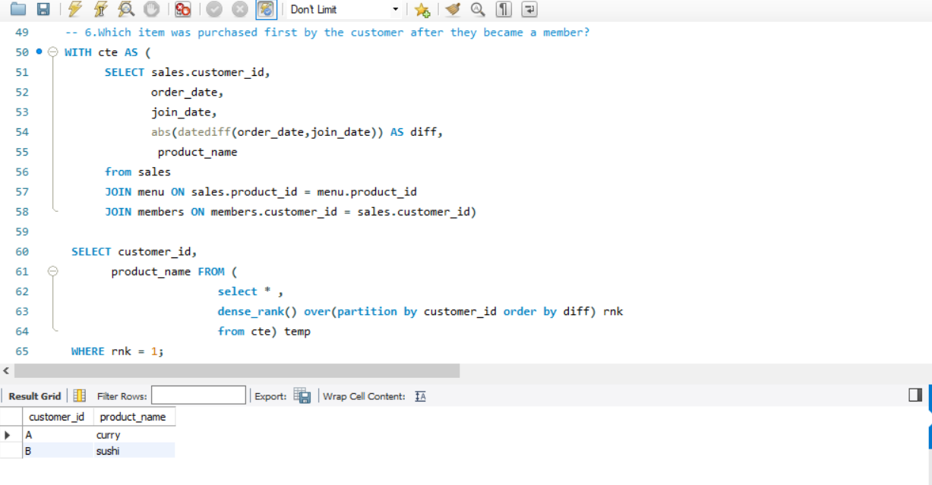

1. **Which item was purchased just before the customer became a member?**

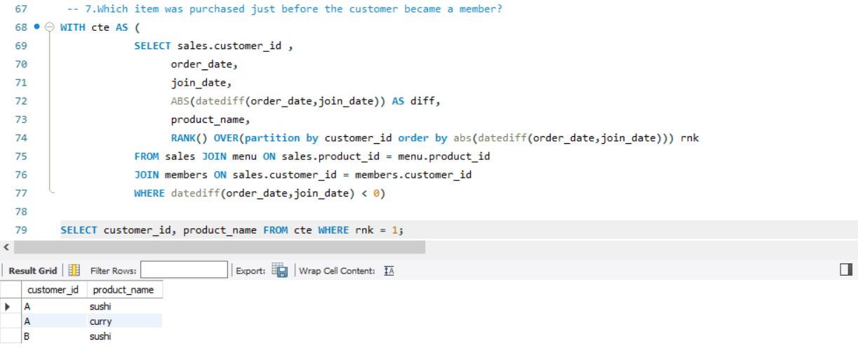

1. **What is the total items and amount spent for each member before they became a member?**

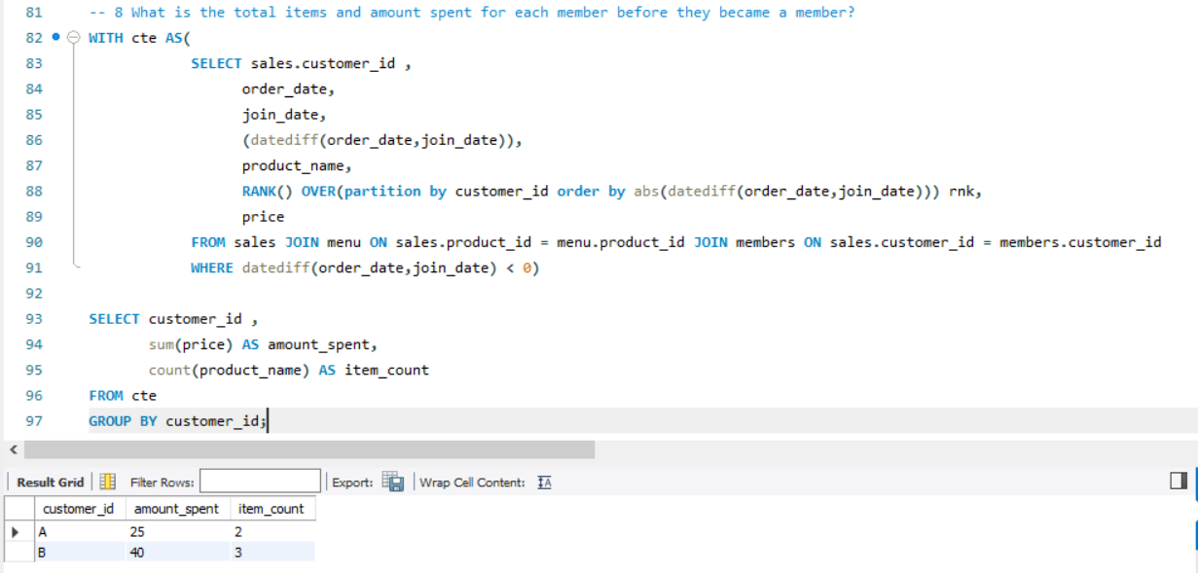

**Insights**:

Okay, Customer B has spent more money before becoming the member.

1. **If each $1 spent equates to 10 points and sushi has a 2x points multiplier - how many points would each customer have?**

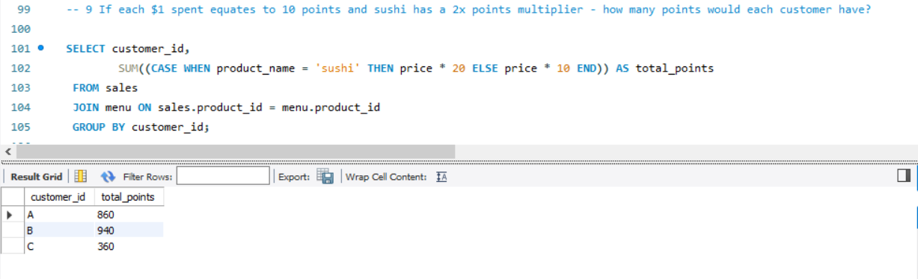

1. **In the first week after a customer joins the program (including their join date) they earn 2x points on all items, not just sushi - how many points do customer A and B have at the end of January?**

**(** My interpretation of this query is that Danny wants to give 20 points to every order that is between join date and last premium date without any restriction of which dish was ordered and afterward 10 points to every order**.)**

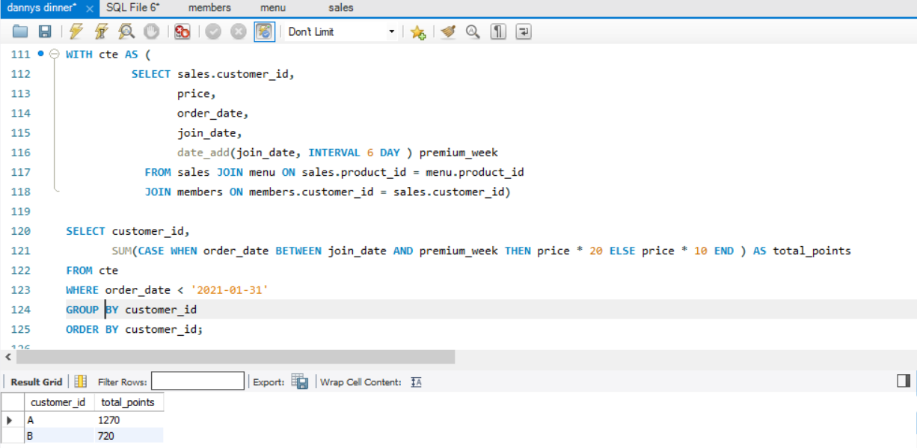

11.**Danny also requires further information about the ranking of customer products, but he purposely does not need the ranking for non-member purchases so he expects null ranking values for the records when customers are not yet part of the loyalty program**.

